**[Linus Torvalds](https://www.ranker.com/review/linus-torvalds/1452170?ref=node_name&pos=4&a=0&ltype=n&l=101211&g=2)**

Linus Benedict Torvalds is a Finnish-American software engineer, he is a creator of Linux kernel, which became the kernel for operating systems such as Chrome OS Android and Linux operating system. His another invention was Git system. Linux is an operating system that become popular for many reasons. This system considered as an excellently well-created product. Formally Linux is distributed under an open source license, giving anyone the opportunity to distribute or change the system. Another invention of Linus Benedict is Git. Git is a source code management system that was initially developed for the purpose of managing Linux, but it can be used to keep track of changes in any set of files. Since Git was developed it praised and become widely used in the software industry. He was honored, along with Shinya Yamanaka, with the 2012 Millennium Technology Prize by the Technology Academy Finland "in recognition of his creation of a new open source operating system for computers leading to the widely used Linux kernel". Also he is a laureate of the Pioneer Prize for the Computer Society of the IEEE in 2014.

Linus Benedict Torvalds was born in December 28, 1969 in Helsinki, Finland. His parents – Anna and Nils Torvalds are journalists. Both of his parents were radicals of the campus at Helsinki University in the 1960s. Benedict Torvalds went to the University of Helsinki in period between 1988 and 1996. In summer of 1989, after his first year at the university, he joined Finnish Army Uusimaa brigade. There he held the rank of Second Lieutenant, with the role of a ballistic calculation officer. After Linus finished his military service he bought computer science book “Operating Systems: Design and Implementation” written by Professor Andrew Tanenbaum. In this book Professor Andrew Tanenbaum describes MINIX, an educational stripped-down version of Unix. In 1990 he continued his university studies and was first exposed to UNIX as a DEC MicroVAX running under ULTRIX. The title of his thesis was Linux: A Portable Operating System. He graduated with a master's degree in computer science from the NODES research group.

Linus Benedict’s interest to the computers manifested in 1981 when he was 11, he explains in a TED interview. He was interested in Commodore VIC-20. Linus started programming in BASIC and later he directly accessed the 6502 CPU in machine code. Linus did not use the assembly language. After that he bought one of the world’s first 32-bit computers for the home use - Sinclair QL and widely modified its operating system. "Because it was so hard to get software for it in Finland, Linus wrote his own assembler and editor (in addition to Pac-Man graphics libraries)" for the Sinclair QL. He also wrote few games. Linus made a clone of Pac-Man and named it Cool-Man. On 5th of January, 1991 he bought a clone Intel 80386 based of IBM PC before receiving his MINIX copy. This allowed him to start working on Linux. He began to work on Linux to improve existing Unix operating system. When he finished his initial work on Linux, he appealed to a community of developers for feedback and Linux spread quickly.

First prototypes of Linux was published in 1991. The first version of Linux (1.0) was published on 14th of March 1994.

In 1991 another computer science student took Linus to the University of Technology to listen to free software-guru Richard Stallman's speech. That was first time when Linus encountered the GNU project. He used Stallman's GNU General Public License version 2 (GPLv2) for the Linux kernel.

In 1996 Linus moved to Santa Clara in California. Here he visited Transmeta and afterwards he accepted a position with Transmeta Corporation. He worked there in period between February 1997 and June 2003. His job was to help develop commercial software to facilitate communication between operating systems and microprocessors of that company. After he started to work in Open Source Development Labs. Since that time it have merged with the Free Standards Group and has become the Linux Foundation. To be closer to the OSDL headquarters in Beaverton, Oregon in 2004 Linus with his family moved to Dunthorpe, Oregon. In period between 1997 and 1999 he participated in 86open to help choose the standard binary format for Linux and Unix. In 1999 leading developers of Linux-based software – Red Hat and VA Linux presented to stock options to Linus. Later both companies become public and Linuses shares shot up to 20 million dollars.

Some popular repositories of Linus Benedict Torvalds

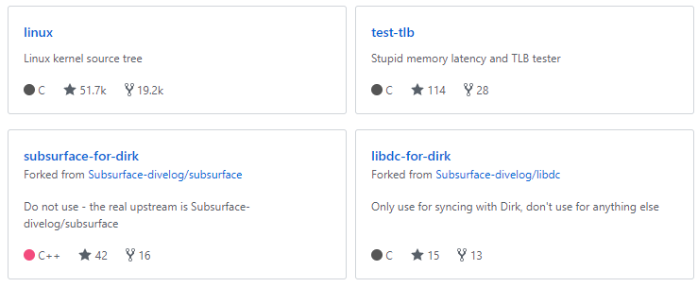

Bibliography

Linfo.org. *Linus Torvalds biography by The Linux Information Project*. [online] Available at: http://www.linfo.org/linus.html [Accessed 10 Nov. 2017].

Torvalds, L. *torvalds (Linus Torvalds)*. [online] GitHub. Available at: https://github.com/torvalds [Accessed 10 Nov. 2017].

En.wikipedia.org. *Linus Torvalds*. [online] Available at: https://en.wikipedia.org/wiki/Linus_Torvalds [Accessed 10 Nov. 2017].

Bernstein, R. *Eight Famous Software Engineers | Husson University*. [online] Husson University. Available at: https://online.husson.edu/famous-software-engineers/ [Accessed 10 Nov. 2017].